**A REPORT OF SEMESTER TRAINING (BTCS 801-18)**

at

# EXTECH DIGITAL

SUBMITTED IN PARTIAL FULFILLMENT OF THE REQUIREMENT FOR THE AWARD

OF THE DEGREE OF

**BACHELOR OF TECHNOLOGY**

(Computer Science and Engineering)



JAN-JUNE, 2025

**SUBMITTED BY:**

Kartik Sharma

2129670

### DEPARTMENT OF COMPUTER SCIENCE AND ENGINEERING

**CHANDIGARH ENGINEERING COLLEGE JHANJERI, MOHALI**



**Affiliated to I.K Gujral Punjab Technical University, Jalandhar**

**(Batch: 2021-2025)**

## DECLARATION

I “ KARTIK SHARMA ” hereby declare that I have undertaken Semester Training at “ **Extech Digital** ” during a period from 15 Jan 2025 to 1st May 2025 in partial fulfillment of requirements for the award of degree of B.Tech (Computer Science and Engineering) at **Chandigarh Engineering College Jhanjeri, Mohali**. The work which is being presented in the training report submitted to Department of Computer Science and Engineering at **Chandigarh Engineering College Jhanjeri, Mohali** is an authentic record of training work.

**KARTIK SHARMA DR. KAMALPREET SINGH**

2129670 ASSISTANT PROFESSOR, CSE

Semester: 8th

**Dr. Rini Saxena**

**HOD CSE**

## ABSTRACT

Nowadays, the hardest thing to do is to find a job.Covid-19 contributes significantly to unemployment; 1.6 billion people are currently unemployed as a result of it. After losing their job, people experience hopelessness, which has a negative impact on their family's health. With a 37.4% unemployment rate as on December 2022, Haryana has the highest rate of unemployment in India.

The Job Search And Recommendation System provides jobseekers with a simple and accessible method to apply for opportunities that match their interests. The jobseekers' privacy and data security are guaranteed by this platform. Businesses post job openings, and job seekers can apply for positions based on their resumes. Each applicant has a webpage of their own.

## ACKNOWLEDGEMENT

It is great pleasure to present this report on the **semester training** undertaken by me as

part of my B.tech degree in Computer Science & Engineering 4th year. I am thankful to

my university for offering me such a wonderful challenging opportunity and I express my

deepest thanks to all coordinators, for providing all the possible help and assistance and

their constant encouragements.

I am extremely thankful to **Dr. Rini Saxena ,** HOD, Computer Science & Engineering, Chandigarh Engineering College Jhanjeri, Mohali (Punjab) for valuable suggestions and motivation.

I am also thankful to all my teachers who have taught me till date in my degree, management of institute and **Dr. Avinash Sharma** , Director Engineering for providing me the opportunity

to get the knowledge.

**Kartik Sharma**

## LIST OF FIGURES

|  |  |  |
| --- | --- | --- |
| **Figure no.** | **Title** | **Page no.** |
| 6.1.1 | Level 0 Data Flow Diagram | 20 |
| 6.1.2 | Level 1 Data Flow Diagram | 20 |
| 6.1.3 | Level 2 Data Flow Diagram | 21 |
| 6.1.4 | Basic Model Flow Chart | 22 |
| 6.2.1 | Login Flow Chart | 23 |
| 6.3.1 | Job Seeker Flow Chart | 24 |
| 6.4.1 | Employer Flow Chart | 26 |
| 6.5.1 | Administrator Flow Chart | 28 |
| 7.2.1 | Landing Page of Website | 33 |
| 7.2.2 | Registration and Login Page of Website | 33 |
| 7.2.3 | Features of Website | 34 |
| 7.2.4 | Search Results of Website | 34 |

## TABLE OF CONTENTS

|  |  |  |
| --- | --- | --- |
| **Chapter no.** | **TITLE** | **Page no.** |
|  | Title Page  Declaration by the Candidate  Acknowledgement  Table of Contents  List of Figures  Abstract | 1  2  3  4  5  6 |
| 1. | **INTRODUCTION**  1.1 Outline of the Project  1.2 Project Overview | 7  8 |
| 2. | **REVIEW OF LITERATURE** | 10 |
| 3. | **PROBLEM DEFINATION AND OBJECTIVES**  3.1 Problem Definition  3.2 Objectives | 12  13 |
| 4. | **METHODOLGY** | 14 |
| 5. | **DESIGN AND IMPLEMENTATION**  4.1 Design Phase  4.2 Implementation Phase | 16  18 |
| 6. | **SYTEM DESIGN**  6.1 Data Flow Diagrams  6.2 Login  6.3 Job Seeker  6.4 Employer  6.5 Administrator  6.6 Facilities | 20  23  24  26  28  30 |
| 7. | **RESULTS and DISCUSSION**  7.1 Result and discussion  7.2 Outputs  7.3 Features | 31  33  35 |
| 8. | **CONCLUSION AND FUTURE SCOPE**  8.1 Conclusion  8.2 Future scope | 36  37 |
| 9. | **REFERENCES** | 39 |

**Chapter-1**

# INTRODUCTION

## 1.1 Outline of the project

AJob Search And Recommendation System is an online site where job seekers can apply for jobs based on their interests**.** The traditional way of finding a suitable job is diminishing day by day**,** which takes time**.** Some of these methods include newspapers, networking, cold calling and door-to-door surveys.

On the other hand; the modern method of job hunting helps job seekers in a crowded market. Some of these methods include creating an online presence,where job seekers can easily create a profile on an online platform like LinkedIn, Indeed, Naukari to find a good opportunity. Job seekers can interpret their skills with the help of Video Resume.

The Internet increases the chances of finding a suitable job, which raises the awareness of young people. The Internet has brought great change to the labor market and employment. With the help of online portals, employers can connect from anywhere in the world, which makes the recruitment process more efficient.

The use of internet by mobile phone users is increasing day by day. Support people by offering many opportunities in one portal, no matter where you come from. You will also receive regular notifications about the latest jobs according to your needs Technologies make things easier, help to find a suitable job and shorten the time.

The purpose of the Job Search And Recommendation System is to provide a platform for job seekers. Nowadays, there is no time to stand in line to get a job; through this portal they can easily get a job by uploading their CV on the web portal.

The job portal is the fastest and cheapest way to reach job seekers from any geographical area widely. To make things easier, it has been developed as an Android application. Job seekers behind everything can find and register for jobs according to their skills. Users can upload reviews so employers can review improvements to their organization.

**1.2 Project Overview**

The primary objective of this project is to design and develop a sophisticated web-based Job Search And Recommendation System that caters to the needs of both job seekers and employers. This comprehensive platform will serve as a one-stop solution for individuals seeking employment opportunities and companies looking to recruit qualified candidates. Leveraging modern web technologies and best practices in user experience design, the portal aims to provide a seamless and intuitive user experience while addressing the diverse requirements of its users.

**Key Features:**

1. **User Registration and Profiles**: Job seekers and employers can create accounts and build comprehensive profiles, including personal information, employment history, skills, and preferences.

1. **Job Search and Filtering**: Job seekers can explore a vast database of job listings using advanced search and filtering options based on criteria such as location, industry, job type, and salary range.

1. **Resume Upload and Parsing**: Job seekers can upload their resumes, which are parsed and stored in a structured format, making it easier for employers to search and match candidates with job openings.

1. **Job Posting and Management**: Employers can post job listings, including detailed descriptions, requirements, and application instructions. They can also manage their job postings, including editing, renewing, or removing listings as needed.

1. **Application Tracking**: Job seekers can track the status of their job applications, receive notifications on application updates, and communicate directly with employers through the platform.

1. **Messaging and Communication**: The platform facilitates communication between job seekers and employers through messaging features, allowing for seamless interaction during the recruitment process.

1. **Analytics and Reporting**: Employers have access to analytics and reporting tools to track the performance of their job listings, including metrics such as views, applications, and hires.

1. **Mobile Responsiveness**: The portal is designed to be fully responsive, ensuring a consistent and optimized user experience across desktop, tablet, and mobile devices.

## Chapter-2

## REVIEW AND LITERATURE

**2.1 Evolution of Job Search And Recommendation Systems:**

Early Job Search And Recommendation Systems emerged in the late 1990s with the advent of the internet, offering basic job listing services. Over time, these portals evolved into sophisticated platforms with advanced features such as resume parsing, personalized job recommendations, and communication tools.

**2.2 User-Centric Design:**

Research emphasizes the importance of user-centric design in Job Search And Recommendation Systems, highlighting the need for intuitive interfaces, streamlined navigation, and responsive layouts. Studies suggest that user satisfaction and engagement are closely linked to the usability and accessibility of the platform.

**2.3 Functionality and Features:**

Effective Job Search And Recommendation Systems offer a range of functionalities to meet the diverse needs of users. Key features include advanced search and filtering options, resume parsing capabilities, job application tracking, messaging tools, and analytics dashboards for employers.

**2.4 Scalability and Performance:**

Scalability and performance are critical considerations in the development of Job Search And Recommendation Systems, particularly given the large volumes of data and traffic they handle. Research emphasizes the importance of scalable architectures, efficient database management, and optimization techniques to ensure fast load times and responsive performance.

**2.5 Security and Privacy:**

Security and privacy concerns are paramount in Job Search And Recommendation Systems, given the sensitive nature of user data involved. Literature highlights the need for robust security measures, including encryption; secure authentication mechanisms, and regular security audits to protect user information from unauthorized access and data breaches.

**2.6 User Experience and Engagement:**

User experience plays a crucial role in the success of Job Search And Recommendation Systems, influencing user satisfaction, retention, and engagement. Studies suggest that personalized recommendations, proactive notifications, and interactive features can enhance user experience and encourage continued usage of the platform.

**2.7 Challenges and Future Directions:**

Despite the advancements in Job Search And Recommendation System development, several challenges persist, including maintaining data accuracy, combating fraudulent listings, and addressing algorithmic bias in recommendation systems. Future research directions include the integration of artificial intelligence and machine learning techniques to enhance personalization and recommendation algorithms.

**Chapter-3**

# PROBLEM DEFINATION AND OBJECTIVES

**3.1 Problem Definition:**

In today's dynamic job market, both job seekers and employers face challenges in connecting with suitable employment opportunities and qualified candidates, respectively. Traditional methods of job search and recruitment are often time-consuming, inefficient, and limited in scope. Job seekers may struggle to find relevant job listings matching their skills and preferences, while employers may face difficulties in reaching and attracting qualified candidates.

The problem addressed by this project is the need for a comprehensive web-based Job Search And Recommendation System that effectively addresses the challenges faced by both job seekers and employers. Specifically, the project aims to provide a solution to the following key problems:

* + 1. **Limited Access to Job Opportunities**: Job seekers often have limited access to a wide range of job opportunities due to the fragmented nature of the job market. Traditional methods such as newspaper classifieds or word-of-mouth referrals may not provide comprehensive coverage of available jobs, leading to missed opportunities.

* + 1. **Difficulty in Identifying Qualified Candidates**: Employers may struggle to identify and attract qualified candidates for their job openings, particularly in competitive industries or niche markets. Traditional recruitment methods such as job fairs or employee referrals may not yield the desired results, resulting in prolonged vacancies and increased recruitment costs.

* + 1. **Lack of Efficiency in the Recruitment Process**: Both job seekers and employers may encounter inefficiencies in the recruitment process, including manual job search, cumbersome application procedures, and lengthy hiring cycles. These inefficiencies can lead to frustration, disengagement, and missed opportunities on both sides of the hiring equation.

* + 1. **Security and Privacy Concerns**: In an era of increasing cybersecurity threats and data breaches, both job seekers and employers are concerned about the security and privacy of their personal information. Traditional job search platforms may not provide adequate safeguards to protect user data, leading to vulnerabilities and breaches of trust.

* 1. **Project Objectives:**

* + 1. **User-Centric Design**: Develop an intuitive and visually appealing user interface that

prioritizes ease of use and accessibility for both job seekers and employers.

* + 1. **Robust Functionality**: Implement a wide range of features and functionalities to meet the diverse needs of users, including advanced search, resume parsing, and communication tools.

* + 1. **Scalability and Performance**: Build a scalable architecture capable of handling large volumes of data and traffic, ensuring fast load times and responsive performance even during peak usage periods.

* + 1. **Security and Privacy**: Incorporate robust security measures to protect user data and privacy, including encryption, secure authentication, and regular security audits.

* + 1. **Continuous Improvement**: Adopt an iterative development approach to continuously improve and enhance the platform based on user feedback, market trends, and technological advancements.

**Chapter-4**

# METHODOLOGY

The methodology for developing the Job Search And Recommendation System involves a systematic approach to planning, designing, implementing, and evaluating the platform. This methodology outlines the key steps and activities involved in each phase of the development process, ensuring the successful creation of a robust and user-friendly portal. Below is the methodology for developing the Job Search And Recommendation System:

* 1. **Project Planning**:
  + Define project objectives, scope, and success criteria in collaboration with stakeholders.
  + Conduct market research to identify user needs, competitor analysis, and emerging trends.
  + Establish a project timeline, resource allocation, and budgetary constraints.

**4.2 Requirement Analysis**:

* + Gather and document functional and non-functional requirements based on stakeholder input and user research.
  + Create user stories, use cases, and personas to understand user needs and usage scenarios.
  + Prioritize requirements and identify dependencies to guide development efforts.

**4.3 Design Phase**:

* + Develop wireframes and mockups to visualize the layout, structure, and user interface of the portal.
  + Design the information architecture, navigation hierarchy, and content organization for intuitive user experience.
  + Create high-fidelity mockups and interactive prototypes for user testing and feedback.

* 1. **Technology Selection**:
  + Choose appropriate technologies, frameworks, and tools based on project requirements, scalability, and team expertise.
  + Select front-end technologies (e.g., HTML/CSS, JavaScript frameworks) and back-end technologies (e.g., Node.js, Python Django, Ruby on Rails) for development.
  + Evaluate third-party APIs and integrations for additional functionality such as geolocation services, authentication, and analytics.

**4.5 Development**:

* + Implement front-end components and user interface elements based on design specifications and mockups.
  + Develop back-end functionality to handle data processing, user authentication, and database interactions.
  + Integrate third-party APIs and services to enhance functionality and user experience.

**4.6 Testing**:

* + Conduct unit testing to validate the functionality of individual components and modules. - Perform integration testing to ensure seamless interaction between front-end and back-end systems.
  + Conduct usability testing with real users to gather feedback on user experience and identify usability issues.
  + Perform security testing, including vulnerability assessments and penetration testing, to identify and mitigate potential threats.

* 1. **Deployment**:
  + Prepare the application for deployment to production servers or cloud platforms. - Configure deployment pipelines and CI/CD workflows for automated deployment and continuous integration.
  + Set up monitoring and logging systems to track application performance and troubleshoot issues in real-time.

**4.8 Documentation and Training**:

* + Document the development process, architecture, and setup instructions for developers and stakeholders.
  + Provide training sessions or documentation for administrators and users on how to use and manage the Job Search And Recommendation System effectively.

**4.9 Maintenance and Support**:

* + Establish a maintenance schedule to address software updates, security patches, and bug fixes.
  + Provide ongoing support and troubleshooting assistance to users and administrators. - Monitor user feedback and performance metrics to identify areas for improvement and future enhancements.

**Chapter-5**

# DESIGN AND IMPLEMENTATION

**5.1 Design Phase:**

The design phase of the Job Search And Recommendation System development project is crucial for translating project requirements into tangible visual and functional elements. This phase focuses on creating wireframes, mockups, and design prototypes that define the user interface, user experience, and overall look and feel of the portal. Below are the key steps and activities involved in the design phase:

**5.1.1** **User Research and Persona Development**:

* Conduct user research to understand the needs, preferences, and behaviors of job seekers and employers.
* Create user personas representing different demographics, job roles, and usage scenarios.

* + 1. **Information Architecture and Navigation Design**:
    - Define the information architecture of the portal, including site structure, navigation hierarchy, and content organization.
    - Design intuitive navigation paths that guide users to key sections such as job search, job posting, user profiles, and messaging.

* + 1. **Wire framing**:
    - Develop low-fidelity wireframes outlining the layout and structure of key pages and features.
    - Focus on content placement, functionality placement, and user flow without detailing visual design elements.

* + 1. **Mockup Design**:

**-**  Create high-fidelity mockups based on the wireframes, incorporating visual design elements such as color schemes, typography, and imagery.

- Design individual page layouts, including the home page, job listing page, job details page, user profile page, and messaging interface.

* + 1. **Responsive Design**:

- Ensure that the design is responsive and adapts seamlessly to different screen sizes and devices, including desktops, tablets, and smartphones.

- Use fluid grids, flexible images, and media queries to create a consistent and optimized user experience across devices.

* + 1. **Prototype Development**:

- Build interactive prototypes to simulate user interactions and demonstrate the functionality of key features.

- Use prototyping tools such as Adobe XD, Sketch, or InVision to create clickable prototypes for user testing and feedback.

* + 1. **Accessibility Considerations**:

- Ensure that the design complies with accessibility standards such as WCAG (Web Content Accessibility Guidelines) to make the portal accessible to users with disabilities.

- Incorporate features such as keyboard navigation, semantic HTML markup, and alternative text for images.

* + 1. **Usability Testing**:

- Conduct usability testing with real users to gather feedback on the design and identify areas for improvement.

- Use techniques such as task-based testing, think-aloud protocols, and user surveys to evaluate the usability and effectiveness of the design.

* + 1. **Iterative Design Refinement**:

- Iterate on the design based on user feedback, stakeholder input, and design best

practices.

- Incorporate usability findings and design recommendations to refine the user

interface, interaction patterns, and visual aesthetics.

* + 1. **Documentation and Design Guidelines**:

- Document the design decisions, rationale, and specifications in a design document or

style guide.

- Create design guidelines outlining typography, color palette, iconography, and UI components for consistency in future development efforts.

By following these steps and activities, the design phase of the Job Search And Recommendation System development project ensures that the final product meets user needs, aligns with project requirements, and provides an engaging and intuitive user experience.

**5.2 Implementation phase**

The implementation phase of the Job Search And Recommendation System development project involves translating the design specifications and requirements into functional code. This phase encompasses both front-end and back-end development activities, as well as database integration, third-party API integration, and deployment setup. Below are the key steps and activities involved in the implementation phase:

* + 1. **Environment Setup**:

- Set up development environments for both front-end and back-end development, including local development servers, version control systems (e.g., Git), and development databases.

- Install necessary development tools, frameworks, and libraries for web development, such as Node.js, React.js, Express.js, MongoDB, and others.

* + 1. **Front-end Development:**

- Develop the front-end components and user interface based on the finalized mockups

and design specifications.

- Use HTML, CSS, and JavaScript (or front-end frameworks like React.js, AngularJS, or

Vue.js) to build interactive and responsive user interfaces.

- Implement client-side functionality for features such as job search, job listing display,

user registration, login/authentication, and profile management.

* + 1. **Back-end Development**:

- Develop the back-end logic and server-side functionality to handle data processing, user

authentication, and database interactions.

- Choose an appropriate back-end technology stack (e.g., Node.js with Express.js, Python

with Django, Ruby on Rails, etc.) based on project requirements and team expertise.

- Implement RESTful APIs or GraphQL endpoints to facilitate communication between the

front-end and back-end components.

* + 1. **Database Integration**:

- Design and implement the database schema to store user data, job listings, applications,

messages, and other relevant information.

- Choose a suitable database management system (e.g., MongoDB, PostgreSQL, MySQL)

based on scalability, performance, and data modeling requirements.

- Implement database CRUD (Create, Read, Update, Delete) operations and establish

database connections within the back-end application.

* + 1. **Third-Party API Integration**:

- Integrate third-party APIs for additional functionality such as geolocation services, job

board syndication, social media authentication, and analytics tracking.

- Follow API documentation and best practices for authentication, authorization, and data

exchange to ensure seamless integration with the portal.

* + 1. **Security Implementation**:

- Implement security measures to protect user data, including encryption of sensitive

information, secure authentication mechanisms (e.g., JWT tokens), and input validation

to prevent injection attacks.

- Follow security best practices such as HTTPS encryption, secure password hashing, and

rate limiting to mitigate common security threats.

* + 1. **Testing**:

- Conduct thorough testing of both front-end and back-end components to identify and fix

bugs, errors, and inconsistencies.

- Perform unit testing, integration testing, and end-to-end testing to ensure the reliability,

functionality, and performance of the portal.

- Use testing frameworks and tools such as Jest, Mocha, Chai, and Selenium for automated

testing and test coverage analysis.

* + 1. **Deployment**:

- Prepare the application for deployment to production servers or cloud platforms such as

AWS, Azure, or Google Cloud Platform.

- Configure deployment pipelines and continuous integration/continuous deployment

(CI/CD) workflows using tools like Jenkins, Travis CI, or GitLab CI.

- Set up load balancers, caching mechanisms, and monitoring tools to optimize

performance, reliability, and scalability in production environments.

* + 1. **Documentation and Training**:

- Document the implementation details, architecture, and setup instructions for developers

and stakeholders.

- Provide training sessions or documentation for administrators and users on how to use

and manage the Job Search And Recommendation System effectively.

* + 1. **Post-Deployment Support**:

- Monitor the live application for performance issues, errors, and security vulnerabilities,

and address them promptly.

- Provide ongoing support and maintenance, including bug fixes, feature enhancements,

and updates based on user feedback and evolving requirements.

**Chapter-6**

## SYSTEM DESIGN

**6.1 Data Flow Diagrams**

Fig. 6.1.2 Level 1 data flow diagram

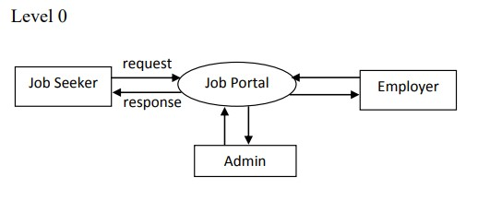

Fig. 6.1.1

Level 0 data flow diagram

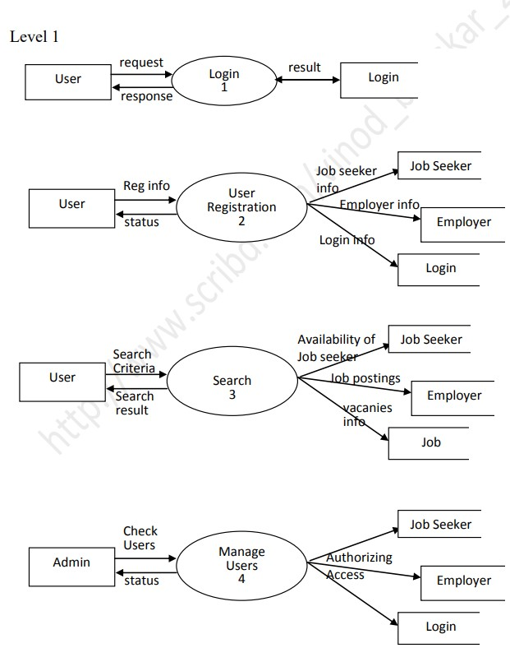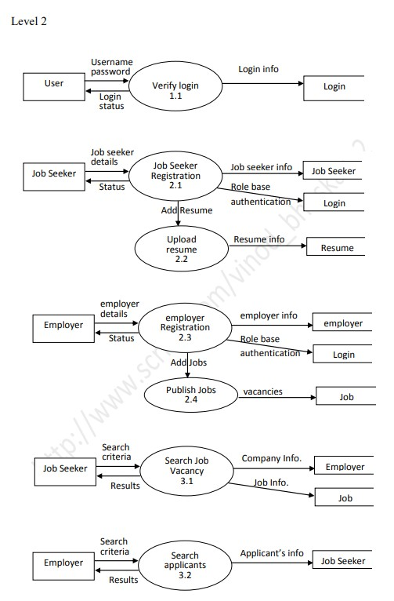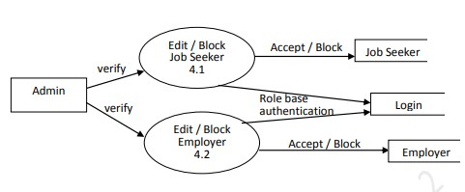

Fig. 6.1.3 Level 2 data flow diagram

The system is broadly divided in to three modules named Jobseeker, Employer and

Administrator. These users got the variety of options and facilities. They do have some facilities that may be common. The vast variety of the options is restricted to the subscribed users. The subscribed users can login to the system and use the all facilities both for the employers and job seekers. The unsubscribed users can also surf through the system but they get only the limited facilities. But the unsubscribed users can seek for the suitable job by using the searching facility available. If they need to utilize more features they should login to the system by filling in the registration form. From the home page the users can login using their user id and password if he/she is a valid user. For the new users there will be provision for new registration. After getting logged in to the system the will be guided to the respective pages. The administrator is the controller of the system operation and act as intermediate between jobseeker and employer.

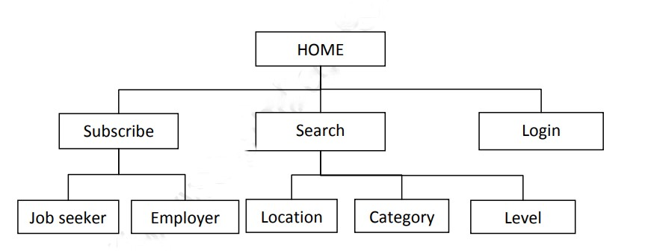

Fig. 6.1.4 Basic model flow chart

### 6.2 LOGIN

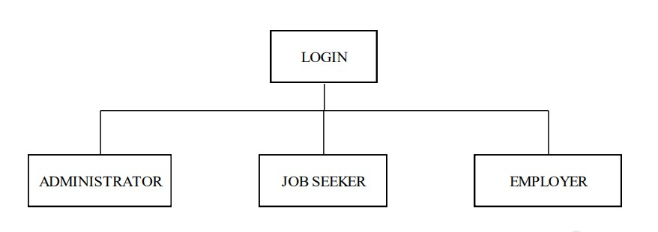 The valid user can login to the system from the home page using their user id and password. The user can login to the system through the home page either as Job seeker or as Employer. From the home page the users can select their respective home pages as per their type of account. User should supply the correct user name and password through the login form as per their subscription. The administrator user can get all the different options so as to control and coordinate the different process. Jobseeker and an Employer can login to the system purposefully.

Fig. 6.2.1 Login flow chart

### 6.3 JOB SEEKER

In the jobseeker module, the main functions comprise uploading resume, updating, searching, applying for the post and unsubscribe. A jobseeker can interactively communicate with the system. An employee can search different way to get a suitable employment like search by level of experience, category and location. In order to get registered with the site the user should upload or edit the resume and user information. They can update the profile as per the improvements, if interested apply for the particular job as per the employer’s commencement on vacancies and user can unsubscribe from the system if he wish. The jobseeker module is the major attraction of the system. The different options help the user to easily seek the employment as per their wish. Upload Resume sub module helps the user to upload the resume for registering in to the job site. The searching is the one of the important function of the Jobseeker module. A jobseeker can search very informatively using search option and the unsubscribe option will help the user to cancel the registration.

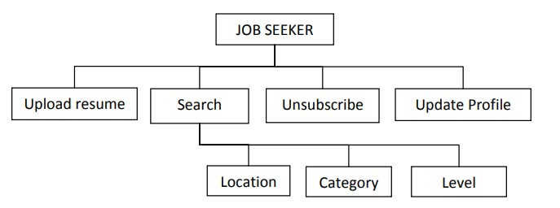

Fig. 6.3.1 Job Seeker flow chart

**6.3.1 Upload Resume**

Upload Resume sub module helps the user to upload the resume for registering in to the job site. Through this user can ensure his/her registration in the site. The user can filled all the details about personal information, curriculum details and about the experience through the given format. And appropriate data is saved in the proper data tables for the future retrieval.

**6.3.2 Search**

The searching is one of the important functions of the Jobseeker module. A jobseeker can search very informatively. This option allow the user to search by Location so as the user can seek if there any vacancies in a particular location. And the user can also search a job as per his Level of experience like a fresher or experienced person. In order to search for a special category job the option can allow searching the job according to Category. The Search option gives a more interactive searching for the user.

**6.3.3 Update Profile**

Update Profile allow user to update their profile as per the new changes and curriculum improvements and achievements. This alternative enables the job seekers to make the necessary changes in their profile so that they can expose them self with all their existing and latest qualifications and capabilities in front of the employers. JOB SEEKER Upload resume Search Unsubscribe Location Category Level Update Profile

**6.3.4 Apply For Job**

The job application is forwarded by the job seeker is also through the Job Seeker module. The mailing facility allows the user to confirm the registration for the particular vacancy as per the Employer’s intimation. If the job seeker apply or conform the registration for the particular job before the given date then only it is acceptable.

**6.3.5 Unsubscribe**

This option allows the user to forward an application for cancellation of their registration. Because of the some circumstances occurs to cancel the registration of the job seeker. The unsubscribe option will help the user to cancel the registration as their wish and will.

**6.4 EMPLOYER**

Job providers can also register in to the site for selecting best employees for the company. An employer can trust on the Employees Portal for fill their vacancies with suitable workers in an interactive and hi-tech way. Employers module include the facilities like Posting the job, View queries, Search, Issue call letter, update profile, unsubscribe.

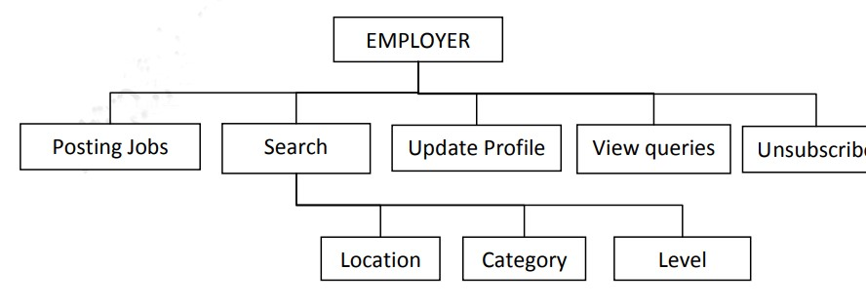

Fig. 6.4.1 Employer flow chart

**6.4.1 Job Posting/Editing**

The role of the Job Posting option is to post the vacancy list of the company to the system. This will include all information about the particular job like job name, EMPLOYER Posting Jobs Search View queries Location Category Level Update Profile Unsubscribe category, level, description, location, and last date of posting. Some time the salary scale also included. And the employer can allow updating the posted information. According to the posted jobs the job seeker applies for the vacancies. And the posted job information pass to the user for referring the availabilities. The employers can the power of updating the posted in formations.

**6.4.2 View Queries**

This function allows the employer to view the details of the job seeker who applied for the particular job so as he could knew the responses for the posted job. Through this view query option the employer can understand the pulses of the current job seekers and the number of applicants for the particular job.

**6.4.3 Search**

Search option allows the employer to search efficient and suitable workers for the company. The employer can search in different way like location, category and level of employee. The proper searching can help the employer to find out the availability of the job seekers. He can search by location in order to check the availability for a particular location. Also the employer can search according to the different level employees and category of job.

**6.4.4 Update Profile**

Update profile use for apply modifications and improvements in the profile. The profile is always visible with the updated format. The profile includes all the information about the company with the facilities and achievements they can have. The profile of the jobseekers should be precisely clear and should be accurate. The updating option allows user to update their profile accordingly.

**6.4.5 Unsubscribe**

This option allows the user to forward an application for cancellation of their registration. The un- subscription can be handled by the administrator. If the employer decide that further no need the help of the system or user want to revise all kind of information then the company can apply for cancellation of registration through the unsubscribe option.

**6.5 ADMINISTRATOR**

The administrator module has the controlling power on this particular job site. The main functions of this module are blocking, view request, searching, update settings, update profile and mailing facility. Only the administrator can block the user. He can view all type of queries and through the proper communication with job seeker and employer administrator can control all the operations. Together all these functions the administrator can manage the role.

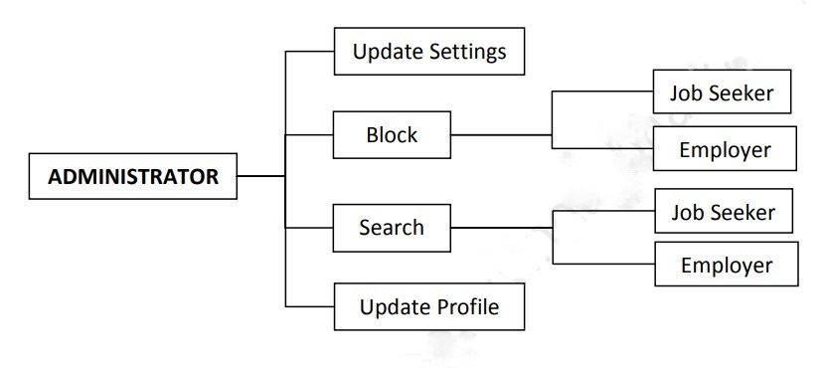

Fig. 6.5.1 Administrator flow chart

**6.5.1 Block**

This function is used for blocking the users. Blocking means the cancellation of the registration of the users. The employers and the job seekers are blocked by the administrator due to some malpractices raised from the users.

**6.5.2 Search**

The search can allow the administrator to seek the suitable employers as well as the job seekers. The available or registered details of both the employers and the job seekers can be viewed and search according to the purpose. Searching is an important function of administrator and by the proper searching of posted jobs and registered jobseekers, administrator intimate the jobseekers about the posted job details as per their qualifications.

**6.5.3 Update Settings**

The Update settings option is used for updating the company settings (Business Rules). These include setting the Posting duration in months, no of postings per month, no of applications available for job seekers etc.

**6.5.4 Update Profile**

This option allows updating the profile for further enhancement. All the updating and the latest information and interactive data should be in the profile. This should include all the information about the job site and the profile should be in an interactive format. The profile of the jobseekers should be precisely clear and should be accurate. The updating option allows user to update their profile accordingly.

### 6.6 FACILITIES

* **Change Password**

The change password option allows the user to change the password in order to maintain security. It is necessary to change the pass word meaningfully and frequently to avoid tracking and hacking.

◻ **Search Engine**

Searching helps the users to search in different way according to their purpose. It has done the searching in an interactive way so as to allow searching by Level of experience, Category and Location. The proper searching can help the employer to find out the availability of the job seekers. He can search by location in order to check the availability for a particular location. Also the employer can search according to the different level employees and category of job. The option can allow the user can search by Location so as the user can seek if there any vacancies in a particular location. And the user can also search a job as per his Level of experience like a fresher or experienced person. In order to search for a special category job the option can allow searching the job according to Category.

* **Edit Profiles**

Edit Profile allow user to update their profile as per the new changes and curriculum improvements and achievements. The profile includes all the information about the company with the facilities and achievements they can have. Through this option the employer can edit or update all kind of information in the profile.

**Chapter-7**

## RESULT AND DISCUSSION

**7.1 Results and Discussion:**

The development of the Job Search And Recommendation System has yielded a comprehensive platform that addresses the needs of both job seekers and employers. Through the implementation of modern web technologies, robust functionality, and user-centric design principles, the portal offers a seamless and intuitive user experience while facilitating efficient job search and recruitment processes. Below are the key results and discussions stemming from the development of the Job Search And Recommendation System:

1. **User Engagement and Satisfaction**:

- The Job Search And Recommendation System has garnered positive feedback from users, with high levels of engagement and satisfaction observed during usability testing and post-launch usage metrics. - Users appreciate the intuitive interface, streamlined navigation, and responsive design, which make it easy to search for jobs, apply for positions, and manage job listings.

1. **Functionality and Feature Set**:

- The portal offers a comprehensive set of features and functionalities that cater to the diverse needs of job seekers and employers.

- Job seekers benefit from advanced search and filtering options, resume parsing capabilities, application tracking, and communication tools, while employers can post job listings, manage applications, and track performance metrics.

1. **Scalability and Performance**:

- The architecture of the Job Search And Recommendation System has proven to be scalable and performant, capable of

handling large volumes of data and traffic without sacrificing responsiveness or user

experience.

- Load testing and performance monitoring have demonstrated the platform's ability to scale

dynamically to meet demand spikes and maintain optimal performance under heavy loads.

1. **Security and Privacy**:

- Robust security measures have been implemented to protect user data and privacy, including

encryption of sensitive information, secure authentication mechanisms, and regular security

audits.

- Compliance with industry standards such as GDPR (General Data Protection Regulation) and

PCI DSS (Payment Card Industry Data Security Standard) ensures that user information is

handled securely and in accordance with relevant regulations.

1. **User Feedback and Iterative Improvements**:

- User feedback has been instrumental in identifying areas for improvement and guiding iterative

enhancements to the portal.

- Continuous monitoring of user interactions, feedback channels, and analytics data allows for

ongoing optimization of features, usability, and performance.

1. **Impact on Recruitment Processes**:

- The Job Search And Recommendation System has had a positive impact on recruitment processes for both job seekers

and employers.

- Job seekers benefit from increased access to job opportunities, streamlined application processes, and improved visibility with employers. Employers, on the other hand, benefit from a larger pool

of qualified candidates, enhanced application tracking capabilities, and improved efficiency in managing job listings.

1. **Future Directions and Enhancements**:

- Looking ahead, future enhancements to the Job Search And Recommendation System may include the integration of

artificial intelligence and machine learning algorithms to enhance job matching and

recommendation capabilities.

- Additional features such as video resumes, skill assessments, and automated candidate screening

could further improve the recruitment process and user experience.

In conclusion, the development of the Job Search And Recommendation System has resulted in a valuable resource for job seekers and employers, providing a user-friendly, secure, and efficient platform for connecting talent with opportunities. By leveraging the insights gained from user feedback and performance metrics, the portal will continue to evolve and improve, maintaining its position as a leading destination for job search and recruitment in the digital age.

**7.2 Outputs**



Fig. 7.2.1 Landing Page of website

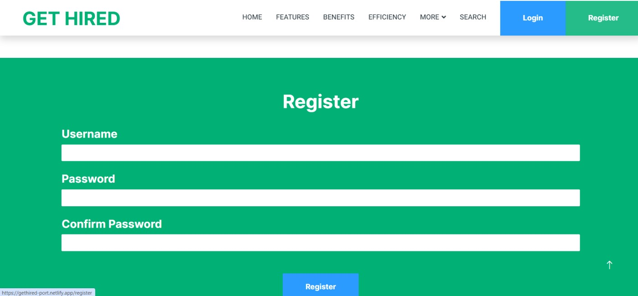

Fig. 7.2.2 Registration and login page of website

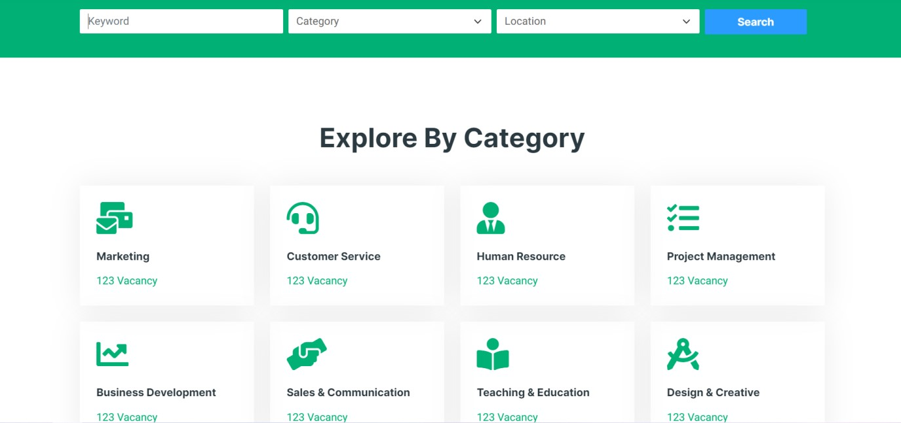

Fig. 7.2.3 Features of website

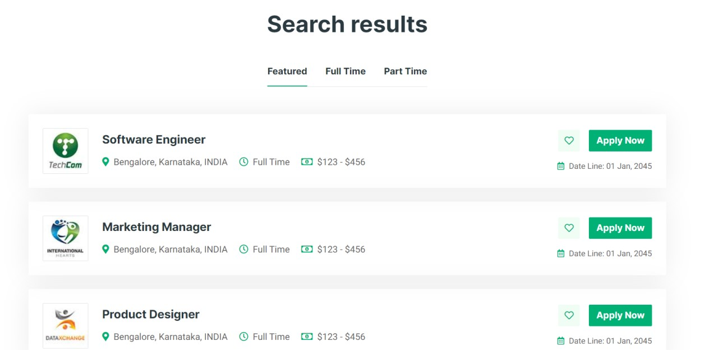

Fig. 7.2.4 Search Result Page of website

### 7.3 Features

**7.3.1 Data-driven Decision Making:**

Advanced data analysis techniques were used to analyze candidate data and make informed decisions based on factors such as success rates, employee retention, and turnover rates.

**7.3.2 Collaborative Hiring Process:**

The platform includes a feature that allows hiring managers to collaborate and make informed decisions, enhancing collaboration and transparency within the organization.

**7.3.3 Search Functionality**:

A responsive search bar that allows users to search for jobs based on keywords, location, and job category.

**7.3.4 Job Listings**:

A dynamic list of job openings, displaying relevant information such as job title, company name, location, and job description.

**7.3.5 User Registration and Login**:

A secure registration and login system for job seekers, allowing them to create and manage their profiles, save job listings, and track their application status. Responsive Design: A mobile-responsive design that ensures a smooth user experience across various devices and screen sizes.

**7.3.6 Job Alerts**:

A feature that allows users to sign up for job alerts based on their search criteria, ensuring they are notified of new job openings as soon as they become available.

User Dashboard: A personalized dashboard for job seekers, displaying their saved job listings, application status, and job alerts.

**7.3.7 Mobile Accessibility:**

Take your job search on the go with GET HIRED's mobile-friendly interface. Whether you’re commuting to work or lounging at home, you can access our platform from your smartphone or tablet, ensuring that you never miss out on important opportunities.

**7.3.8** **User-Centric Design**:

At the core of our Job Search And Recommendation System is a user-centric design that prioritizes ease of use, intuitive navigation, and personalized experiences. We have

meticulously crafted the interface to be visually appealing, mobile-responsive, and accessible to users of all backgrounds and skill levels. The clean layout, intuitive search functionality, and interactive elements create a seamless user experience that keeps job seekers engaged and motivated in their job search journey.

### Chapter-8

**CONCLUSION AND FUTURE SCOPE**

#### 8.1 Conclusion

The development of a Job Search And Recommendation System represents a significant endeavor aimed at addressing the needs of both job seekers and employers in today's competitive job market. By leveraging modern web technologies, robust functionality, and user-centric design principles, the Job Search And Recommendation System offers a comprehensive solution for connecting talent with opportunities. Through the systematic application of methodologies and the utilization of appropriate technologies, the development team has successfully delivered a platform that streamlines the job search and recruitment process while enhancing user experience and satisfaction.

The Job Search And Recommendation System's user-friendly interface, advanced search and filtering capabilities, and seamless communication tools have resulted in increased engagement and efficiency for both job seekers and employers. The scalable architecture, robust security measures, and continuous monitoring ensure the reliability, performance, and security of the platform, even under high traffic and data loads.

Moving forward, the Job Search And Recommendation System will continue to evolve and adapt to meet the changing needs of users and the demands of the job market. Ongoing enhancements, iterative improvements, and integration of emerging technologies will further enhance the portal's functionality, usability, and effectiveness. By maintaining a focus on user feedback, performance metrics, and industry trends, the Job Search And Recommendation System will remain a valuable resource for job seekers and employers, facilitating connections and opportunities in the dynamic landscape of employment.

#### 8.2 Future Scope

Despite the successful development and deployment of the Job Search And Recommendation System, there are several avenues for future enhancements and expansions to further improve its functionality, user experience, and market competitiveness. The following are potential areas of future scope for the Job Search And Recommendation System:

* + 1. **Artificial Intelligence and Machine Learning Integration:**

-Implement AI-driven features such as smart job recommendations, personalized career

coaching, and predictive analytics to match candidates with relevant job opportunities

more accurately.

-Utilize machine learning algorithms to analyze user behavior, preferences, and trends,

enabling proactive notifications, customized job alerts, and automated candidate

screening.

* + 1. **Enhanced Mobile Experience**:

-Develop native mobile applications for iOS and Android platforms to provide a seamless

and optimized user experience on mobile devices.

-Leverage mobile-specific features such as push notifications, geolocation services, and

biometric authentication to enhance usability and engagement.

* + 1. **Video Resumes and Virtual Interviews**:-

-Integrate video resume functionality to allow job seekers to showcase their skills,

personality, and enthusiasm directly to employers.

-Implement virtual interview features, including live video interviews, recorded responses,

and automated interview scheduling, to streamline the hiring process and improve

candidate evaluation.

* + 1. **Skill Assessment and Training Resources**:

-Offer skill assessment tools and online training resources to help job seekers enhance their qualifications, bridge skill gaps, and prepare for job interviews.

-Partner with educational institutions, industry experts, and certification providers to offer accredited courses, certifications, and professional development opportunities.

* + 1. **Global Expansion and Localization**:

-Expand the reach of the Job Search And Recommendation System to new markets and regions by supporting multiple languages, currencies, and cultural preferences.

-Customize the platform to meet the unique needs and requirements of specific geographic regions, industries, and job markets.

* + 1. **Blockchain Technology for Credential Verification**:

-Integrate blockchain technology to provide secure and tamper-proof verification of job seekers' credentials, certifications, and work experience.

-Implement decentralized identity solutions to empower users with ownership and control over their personal data and credentials.

* + 1. **Social Networking and Community Building**:

-Foster a vibrant online community within the Job Search And Recommendation System, allowing users to connect, network, and share insights, advice, and job opportunities.

-Integrate social networking features such as user profiles, activity feeds, and discussion forums to facilitate peer-to-peer interaction and support.

* + 1. **Data Analytics and Insights**:

-Enhance analytics and reporting capabilities to provide deeper insights into user behavior, job market trends, and recruitment effectiveness.

-Offer actionable analytics dashboards for employers to track the performance of their job listings, measure candidate engagement, and optimize recruitment strategies.

* + 1. **Voice Search and Natural Language Processing:**

-Implement voice search functionality to enable users to search for jobs and interact with the portal using natural language commands.

-Utilize natural language processing (NLP) algorithms to improve search accuracy, semantic understanding, and contextual relevance of job listings and candidate profiles.

* + 1. **Continuous Improvement and User Feedback:**

-Maintain a culture of continuous improvement by soliciting user feedback, conducting usability testing, and monitoring key performance indicators (KPIs).

-Incorporate user feedback into iterative development cycles to address pain points, enhance features, and prioritize future enhancements.

By exploring these avenues for future scope and innovation, the Job Search And Recommendation System can remain at the forefront of the industry, providing value to both job seekers and employers while adapting to evolving market dynamics and technological advancements.

**Chapter-9**

**REFERENCES**

1. file:///C:/Users/HP/Downloads/IJCRT2104174.pdf
2. <https://core.ac.uk/download/pdf/77979433.pdf>
3. [https://www.crescendo-global.com/blog/2022/08/what-are-the-major-challenges-faced-by-jobseekers-in-conducting-an-effective-job-search](https://www.crescendo-global.com/blog/2022/08/what-are-the-major-challenges-faced-by-job-seekers-in-conducting-an-effective-job-search)